**Magnetic Mirror Effect in Magnetron Plasma:  
Modeling of Plasma Parameters**

*Submitted in partial fulfillment of the requirements for the degree of*

Bachelor of Technology

in

**Mechanical Engineering**

*by*

## 18BEM0145 Sashi Kant Shah 18BME2104 Kaushal Timilsina 18BME2109 Hrishav Mishra

**Under the guidance of  
 Prof. / Dr. Sitaram Dash**

**School of Mechanical Engineering**   
 VIT, Vellore.



February 15,2022

**DECLARATION**

We hereby declare that the thesis entitled “Magnetic Mirror Effect in Magnetron Plasma: Modeling of Plasma Parameters" submitted by us, for the award of the degree of *Bachelor of Technology in Mechanical Engineering* to VIT is a record of bonafide work carried out by me under the supervision of Professor Sitaram Dash.

We further declare that the work reported in this thesis has not been submitted and will not be submitted, either in part or in full, for the award of any other degree or diploma in this institute or any other institute or university.

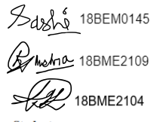

Place : Vellore   
Date : 15th February 2022  **Signature of the candidate**

**CERTIFICATE**

This is to certify that the thesis entitled “Magnetic Mirror Effect in Magnetron Plasma: Modeling of Plasma Parameters” submitted by **18BEM0145-Sashi Kant Shah, 18BME2104 Kaushal Timilsina &18BME2109 Hrishav Mishra**, VIT University, for the award of the degree of *Bachelor of Technology in Mechanical Engineering*, is a record of bonafide work carried out by him under my supervision during the period, 01. 12. 2021 to 30.04.2022, as per the VIT code of academic and research ethics.

The contents of this report have not been submitted and will not be submitted either in part or in full, for the award of any other degree or diploma in this institute or any other institute or university. The thesis fulfills the requirements and regulations of the University and in my opinion meets the necessary standards for submission.

Place : Vellore

Date : 15th February 2022 **Signature of the Guide**

#### Internal Examiner External Examiner

Head of the Department Mechanical Engineering

## ACKNOWLEDGEMENTS

We would like to express our special gratitude to our project guide Prof. Sitaram Dash for his personal support and advice to carry out the thesis and complete it. We would further like to extend our gratitude to the School of Mechanical Engineering and VIT for providing us with this opportunity to enhance our previous semester knowledge practically through this capstone project and strengthen our understanding through the thesis for the same. We have got to learn a lot more about this project regarding the understanding and improvement of practical applications of Magnetron sputtering which will be very helpful for us as we progress in our field of study. We are also grateful for having the opportunity of learning team work which has helped us in recognizing our potential both on an individual as well as a team level. Being able to understand how each and every one of us are able to contribute through our individual thinking and building the outcome through amalgamation of the same is this something we are truly thankful for.

18BEM0145 Sashi Kant Shah   
18BME2104 Kaushal Timilsina   
18BME2109 Hrishav Mishra

# Executive Summary

The aim of this work is to understand the magnetic mirror configuration that is ideal in in a magnetic plasma trap chamber which can be used in Magnetron sputtering. Particles in a plasma have different speeds depending on the initial distribution which is based on parameters like the plasma temperature. The speeds of particles change depending on the electric and magnetic fields. Based on the magnetic mirror effect, one can determine which particle (having certain velocities) can escape the magnetic trap and which of those are reflected. The less the particles escape the magnetic trap, the more of the flux is used in forming coatings and less of the ionized gas is wasted. This is very useful in understanding the required gas supply and rate of deposition.

The model used in the project is mostly similar to the single particle model, where in a collection of particles, each particle evolves under the influence of the electric and magnetic fields set up by the apparatus; governed by the Lorentz force. However, we incorporate a little bit of the Kinetic theory in that we are interested in different initial velocity distributions for particles in the plasma and how the velocity distribution changes over time. To achieve this in a simulation, the Lorentz force equations are discretized and then solved using the Boris Algorithm; a standard algorithm for simulating charged particles in electric and magnetic fields.

**Key words:** Magnetic mirror, Magnetron sputtering **,** Lorentz force , Kinetic theory, Boris Algorithm

**CONTENTS Page**

**No.**

#### Acknowledgement i

Executive Summary ii

Table of Contents Iii

List of Figures ix

List of Tables xiv

Abbreviations xvi

Symbols and Notations xix

1. INTRODUCTION 1
   1. Objective 1
   2. Motivation 1
   3. Background 1
2. PROJECT DESCRIPTION AND GOALS 1
3. TECHNICAL SPECIFICATION 2
4. DESIGN APPROACH AND DETAILS (as applicable) 4
   1. Design Approach / Materials & Methods 5
   2. Codes and Standards 6
   3. Constraints, Alternatives and Tradeoffs 8

#### SCHEDULE, TASKS AND MILESTONES 9

1. **PROJECT DEMONSTRATION 11**
2. RESULT & DISCUSSION 12

|  |
| --- |
| 1. **SUMMARY 13** |
| **9 REFERENCES 16** |
| **APPENDIX A**  **List of Figures**   |  |  |  |  | | --- | --- | --- | --- | | **Figure No.** |  | **Title** | **Page No.** | | 1 |  | Magnetron Sputtering | 14 | | 2 |  | Simulation Flow Chart | 14 |  List of Tables **Table No. Title Page No.**   |  |  |  |  | | --- | --- | --- | --- | | 1 | Gantt Chart |  | 15 | |

1. **INTRODUCTION**

**OBJECTIVE**

The objectives of the project define the structure of our algorithm and are as follows:

**1. Single Particle Method**   
To simulate charged particles that evolve under the influence of electric and magnetic fields; as governed by the Lorentz force.

**2. Field Configurations**   
To simulate a few different configurations of electric and magnetic fields- some describing apparatus like coils; some describing analytic expressions for fields and to study the different evolution of particles.  
 **3. Kinetic Theory**  
 To study different initial velocity distributions and how the velocity distribution of particles changes as the particles dynamically evolve. Parameters like the Plasma temperature are to be studied under this topic.  
**4. Analysis**   
To analyze different batches or collections of particles, subjected to different field configurations.

**1.2 MOTIVATION**  
Currently large number of researches going on to use of plasma in daily practical life, and as the theme of our project lies on using magnetic field and electric field to study the efficiency of magnetic sputtering, it gave us the motivation to choose the topic for our thesis. Magnetron sputtering now makes a significant impact in application areas including synthesis of hard, wear-resistant coatings, low friction coatings, corrosion-resistant coatings, decorative coatings and coatings with specific optical, or electrical properties.  DC magnetron sputtering can be used for synthesizing Ag nanoparticles in which their size can be precisely controlled. At constant sputtering current and deposition time, the size of Ag nanoparticle is inversely proportional to the target-substrate distance.

**1.3 BACKGROUND**Our Institute has a lot of facilities for learning and researching upon Engineering Physics which is one of the core subjects in Mechanical Engineering. The physical principles governing practical applications are significant to enhance design capabilities and augment utilization aspects. This provides the starting push to choose Magnetic Mirror Effect as our project, apart from which the enthusiasm we shared in learning and understanding plasma physics and engineering. This is the basis of selection of our topic of research for the Capstone Project.

**2.PROJECT DESCRIPTION AND GOALS**

**a. Description**

A magnetic mirror configuration is important in a magnetic plasma trap chamber such as that used in Magnetron sputtering. Particles in a plasma have different speeds depending on the initial distribution which is based on parameters like the plasma temperature. The speeds of particles change depending on the magnitude of applied electric and magnetic fields. Based on the magnetic mirror effect, one can determine which particle (having certain velocities) can escape the magnetic trap and which of those are reflected. The less the particles escape the magnetic trap, the more of the flux is used in forming coatings and less of the ionized gas is wasted. This is very useful in understanding the required gas supply and rate of deposition.

The kinetic energy and the magnetic moment of a charged particle in a magnetic field are conserved if there are no external sources. If the magnetic field has a gradient, the   
component of the velocity of the particle parallel to the magnetic field changes and might

1

decrease to zero and increase in the opposite direction: which is observed as the particle

being reflected. This setup is important to understand and control how the ions are contained in and lost from a magnetron sputtering chamber.

**b. Goals**

•To simulate charged particles that develop affected by electric and attractive fields; as

administered by the Lorentz power.

•To simulate a couple of designs of electric and attractive fields-some portraying devices like curls; some depicting logical articulations for fields and to concentrate on the different development of particles.

•To concentrate on various introductory speed circulations and how the speed dispersion of particles changes as the particles advance. Boundaries like the Plasma temperature are to be considered under this subject.

•To investigate various groups or assortments of particles, exposed to various field configurations.

**3.TECHNICAL SPECIFICATION**

**1 Plasma as a system**   
Various models are used to describe Plasma as a system. Some of the common approaches are:

1. **Single particle description**  
 This model is used to describe the motion of a charged particle under the influence of electric and magnetic fields. The particle’s motion is described by the Lorentz force   
   
Describing many particles evolving under the influence of Lorentz force, it is easy to describe a plasma assuming that the mean free path of the particles is much larger than the dimensions of the chamber; meaning that particles hardly ever collide. This is to say that in the simplest case, under this model particle evolve under the influence of electric and magnetic fields but the particles do not produce any electric and magnetic fields of their own or affect the external applied fields and hence also do not interact with other particles.  
**2. Kinetic theory**   
The kinetic theory describes the plasma as collection of particles whose state (position and velocity) is treated as a random variable with a density function *f* (*x, y, z, vx, vy, vz, t*) which describes the number of particles at position (x, y, z) at time t with velocities between *vx* and *vx* + *dvx*, *vy* and *vy* + *dvy*, *vz* and *vz* + *dvz* in directions x, y and z respectively. For a simpler notation *f* (*x, y, z, vx, vy, vz, t)* is denoted as *f* (***x****,* ***v****, t*). The expression  
  
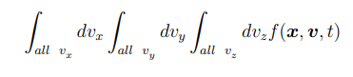  
gives the number of particles at position x, at time t. For a simple choice of notation, it if often written as  
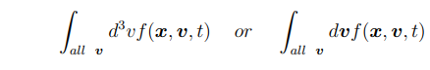  
A density function is said to be normalized if

2  
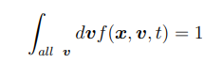   
Such a density function is also denoted with a hat as *f*ˆ(***x****,* ***v****, t*).  
The average velocity *v*¯ for a density function *f*ˆ(***x****,* ***v****, t*) is calculated as  
  
Various other features of the distribution are: the Root Mean Square velocity vrms, the average absolute velocity |v| , the average velocity in z direction |vz|, etc. The evolution of the particles is described as the changing of the density function. Boltzmann equation is often used to describe this dynamics:  
  
While it may look complicated at first, the left hand side of the equation is actually just a short form for:  
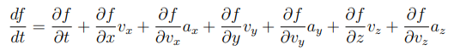  
For simplicity, let us look at the 1-dimensional (2-phase dimensional) version of this expression  
  
If the right hand side of the Boltzmann equation were zero, in 1-dimension (2-phase dimensions), it would read:  
  
This would mean that the distribution function is unchanging (in its own frame). If particles were not interacting and there was no external disturbance, this is exactly what would happen. This is why with the expression on the right hand side set to zero, the Boltzmann equation is said to be collision less. Adding a non-zero expression on the right hand side would account for interactions between the particles or the effect of external disturbances.  
  
**3.Fluid model**   
The fluid model is describes the plasma in terms of macroscopic variables like Pressure, temperature, average velocity, density, flux; like ordinary fluid dynamics. The governing Partial Differential Equations are obtained by taking moments of the Boltzmann equation, or a special case of the Boltzmann equation called the Vlasov equation. Such a procedure gives rise to:   
The continuity equation:  


and the Cauchy momentum equation:  
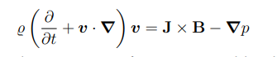  
 3

Higher moments yield other equations for quantities like the entropy. The fluid equations average over the velocity distribution of the particles to obtain the macroscopic variables like Pressure and Temperature, as discussed earlier- by taking moments of the Kinetic equations like the Boltzmann equation or the Vlasov equation.

**4. Magnetohydrodynamics**

Magneto hydrodynamics(MHD) is an extension of the fluid model of describing a plasma. In a first approximation, the magnetic and electric fields acting on the fluid and the currents generated are now solved using Faraday’s law:  
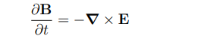  
and the Ampere’s law:  
  
The full set of Maxwell’s equations can also be coupled with the fluid. MHD description of a plasma also describes dynamic waves such as Alfvén waves and magneto sonic waves. MHD theory can also be used to describe interaction of the plasma with electromagnetic waves, for example those from a LASER source relevant to LASER plasma processes in surface engineering. Ideal MHD studies plasma as a fluid of single species, however, multi-species plasma can also be studied

**5. The model used in the project**

In the context of plasma processes like Magnetron Sputtering where particles have a considerably large mean free path, we have decided not to use the fluid model and the MHD descriptions of a plasma. In such processes, it is almost always the case that the strength of the electric and magnetic fields applied by the apparatus is far stronger than the electric and magnetic fields generated by charged particles in a plasma. This approximation allows us to avoid solving Maxwell’s equations and use only the Lorentz force. The model used in the project is mostly similar to the single particle model, where in a collection of particles, each particle evolves under the influence of the electric and magnetic fields set up by the apparatus; governed by the Lorentz force. However, we incorporate a little bit of the Kinetic theory in that we are interested in different initial velocity distributions for particles in the plasma and how the velocity distribution changes over time; as it is important to understand the velocity distribution to characterize the reflection and loss of particles in a magnetic-mirror like trap that may be setup in the plasma chamber.

**4. DESIGN APPROACH AND DETAILS   
4.1 Design Approach / Materials & Methods**  
As discussed earlier, we evolve individual particles in the plasma with the Lorentz force. To achieve this in a simulation, the Lorentz force equations are discretized and then solved using the Boris Algorithm; a standard algorithm for simulating charged particles in electric and magnetic fields.

**Lorentz Force**

The equations of motion for a charged particle under the influence of Electric and Magnetic fields is described by the Lorentz Force in the S.I. units as

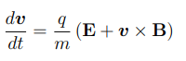

as discussed earlier, along with the expression for the velocity.

4  
  
These equations are discretized to obtain  
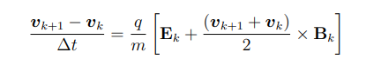  
from the Lorentz Force equation, and  
  
from the expression for velocity, where the subscript k denotes the kth time step.

**Boris Algorithm**

The discretized Lorentz equations may be solved using the Boris Algorithm, as we do in this project. The Boris Algorithm splits the discretized Lorentz equation into three equations.

4  
  
which is often called the first half of the electric pulse.  
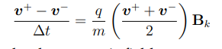  
which is often called rotation by the magnetic field.  


which is almost the discretized Lorentz equation except that (***v***+ + ***v****−*) is substituted for (***v****k*+1 + ***v****k*). However, subtracting the first electric pulse equation from equation gives (***v***+ + ***v****−*) = (***v****k*+1 + ***v****k*), giving the discretized Lorentz equation.This means that the Boris algorithm is equivalent to the discretized Lorentz equation.

The equations of the Boris Algorithm can be written slightly different as

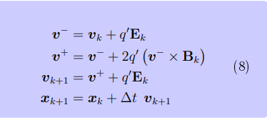  
along with discretized position equation where  These equations are used to update the velocity of the particle under the influence of the Lorentz force under the Boris update strategy.

**2 Particle Sampling- kinetic theory**   
As discussed earlier, kinetic theory of plasma uses density function and its evolution to describe a plasma. We pointed out that we will be using some aspects of kinetic theory in our project; in that we will initialize the batches (collections) of particles based on certain distributions. This will allow us to study parameters like the plasma temperature, in our project  
 **5**

**Maxwellian distribution**

One important density function often used in the kinetic theory of plasma is the Maxwell-Boltzmann distribution often called the Maxwellian which has the density function

5  
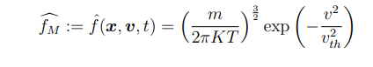

Where  
   
Some features of the Maxwellian are:

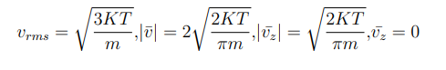  
 **Parabolic distributions**  
 We are also interested in defining other density functions to do the sampling. The simplest density function to try would be to have all particles have the same velocity i.e. a Dirac delta function distribution. Another simple distribution would be a uniform distribution between two velocities, where a particle is equally likely to have any velocity in the range.  
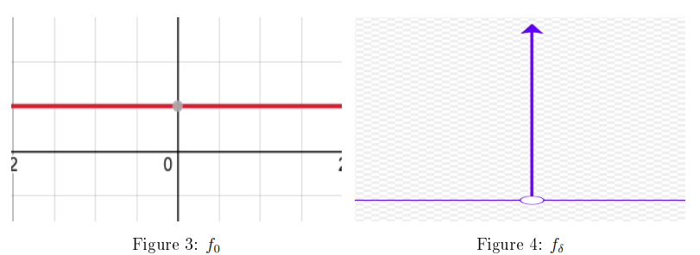

Functions that look like f0 might define he uniform distribution while functions like fδ might describe the Dirac delta distribution. The figure for f0 was generated using desmos graphing calculator while the figure for fδ was snipped from the image in wikipedia for the Dirac delta function. We define initialization strategies based on uniform and Dirac delta distributions in our simulations.  
Parabolic functions in a given range also seem like interesting distributions and yet simple to work with. After some trial and error, two functions that seem interesting are:  
 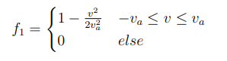

5

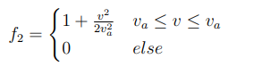

These functions can be normalized as

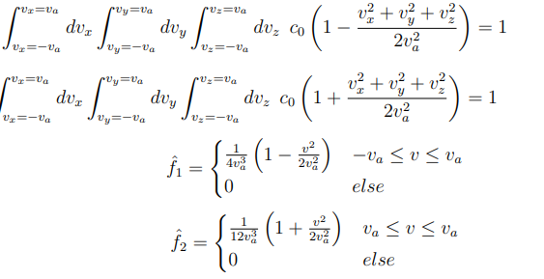  
The graph of these functions (considering v as a single variable) were generated using desmos graphing calculator. The figures represent ˆf1 and ˆf2 extrapolated to beyond the defined range  
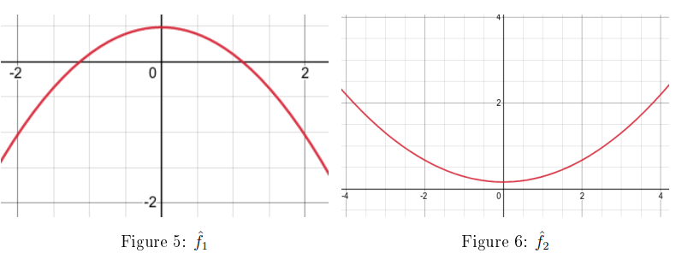  
In the upper half of the plane, ˆf1 looks approximately like a Gaussian distribution which the Maxwellian is for a distribution of velocity (not speed) for a fixed temperature. ˆf2 is sort of the opposite of ˆf1. But given that the functions are defined in a limited range, the integrals do not diverge.  
  
**4.2 Codes and Standards**

The simulation is programmed in jupyter notebook files (.ipynb extensions) that run python and markdown. The notebooks are available in the following Github repository, in the notebooks folder.

**Github Repository**  
<https://github.com/18BME2104/MagneticMirror>

6

**Algorithm Outline**   
Different aspects of the program are discussed based on the different notebooks (ipynb files) that describe them.

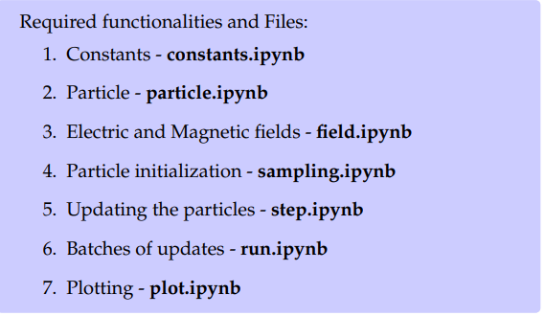  
 **Constants - constants.ipynb**   
  
The **constants.ipynb** notebook describes some constants useful in the program. Some useful constants are *e* (electron charge) *me* (electron mass), charges and masses of ions in the plasma, a.m.u (atomic mass unit), NA (Avogadro’s number),  (permittivity of vacuum), µ0 (permeability of vacuum), K or kB (Boltzmann’s constant), etc.  
 **Particle - particle.ipynb**   
  
The **particle.ipynb** notebook describes the state of a particle; its position, velocity, mass, charge, name, and optionally acceleration (which is set to 0 as default if it is not required to track the acceleration of a particle) as of now.   
Currently the Boris algorithm as discussed earlier, is an update strategy defined to update the state of a particle. Other strategies could be defined in new functions in the class. However, Boris algorithm is good enough for us to get started.

**Electric and Magnetic fields - field.ipynb**Electric and Magnetic field configurations described in **field.ipynb**.   
Currently **Uniform Electric field** and the **Radial Electric field** (the field depends on the particle’s position) created by an electrode are available to set up electric fields. Uniform Magnetic field and Magnetic field created by a Helmholtz coil and that by two Helmholtz coils are available.

Other Electric and Magnetic fields can be defined as functions in this class. These fields could be based on modeling of apparatus used to create electric or magnetic fields such as coils, or based on analytic expressions.

**Particle initialization - sampling.ipynb**  
 The initial positions and velocities of the particles play an important role in the evolution of their state under the influence of electric and magnetic fields. The initial distribution of positions and velocities define where the particles start in the setup (or lab apparatus); for example where they are injected into a sputtering chamber through valves, and what velocities they start with; for example what potential they are accelerated through or what parameters were used for the pumps used to pump the particles in.  
 7

The tracking of initial distribution is also important in determining how the magnetic mirror effect is observed in the plasma. The Sampler class samples initial positions and velocities for a given number of particles based on some available schemes.   
Currently positions can be sampled such that all particles start at the **same position** (like for example if injected through a port**), at the same distance** but randomly distributed in

angular positions relative to some point(origin as of now). Velocities can be sampled such that particles have the **same speed**, **same velocity** or **Maxwellian distributed speeds** or **Maxwellian distributed velocities**.

The initial positions and velocities could be passed around in lists but to be able to reuse some generated samples, and avoid sampling all the time, it is convenient to write sampled positions and velocities to files (csv format seems convenient). This functionality is described as:

**Updating the particles - step.ipynb**  
 The Step class is concerned with **initializing particles**, **defining the fields**, and **updating the states of the particles** (positions and velocities) under the action of electric and magnetic fields

To use sampled positions and velocities that have been saved in csv files, some reading functionality is useful to load these positions and velocities to be used during initialization.

**4.3 Constraints, Alternatives and Tradeoffs** The major portion of the work to be done to achieve this includes working on the **run.ipynb** notebook. To be able to understand the simulation; to check if works correctly and to understand the plasma behavior, we also need to define functionalities to plot different parameters like particle positions and velocities. These functionalities will be defined in **plot.ipynb** notebook, which can be imported into **ryn.ipynb** and **step.ipynb** notebooks to plot these quantities when the simulation is running, or from saved data.

**Batches of updates - run.ipynb**   
The Run class is concerned with running the steps defined by the Step class in **step.ipynb**. This includes creating batches of particles, updating them under the influence of electric and magnetic fields and removing them if they move out of the region of interest or for example are absorbed during a coating process. New batches of particles can be created to model the flow of particles as in a plasma chamber setup. Functionality to change the fields; for example changing the Voltages in electrodes or Currents in the coils, are also defined. This better models the control of plasma supply and electric and magnetic field control apparatus as in a laboratory.

**Plotting - plot.ipynb**   
The plot class is used to define functionalities to draw particle positions, plot positions and velocities of particles, as the system evolves like a lab apparatus. These functionalities are imported into run.ipynb; and if required other notebooks, to be used when the simulation is running; or optionally from saved data. Work on this notebook is yet to be started.

**Understanding of the plasma**   
The big question, is that once we have a simulation running, how do we do analysis on the

plasma so that the project helps improve our understanding of a plasma system? The sampling aspect of the project, will allow us to understand how different parameters of the plasma like the temperature; when it enters the chamber affect the behavior of the plasma.

8

We can also study for example, the velocity distribution of the particles as they evolve in the chamber. Studying different field configurations; even simple functionalities like being able to change the Voltage of an electrode to change the electric field- like one might with a real apparatus, will help us understand the behavior of plasma under different or changing fields. Such strategies will allow us to understand how to contain a plasma in chamber; and one such instance would be a magnetron sputtering chamber where one could study the magnetic mirror effect. The magnetic mirror effect in a magnetron sputtering chamber serves as one example of studies we could do on the plasma parameters, studying a plasma in simulation. So our title serves as an example for what we could do with such a project. We have learned through the course of doing the project that more could be achieved with such a system than what we initially planned to focus on.

**5. SCHEDULE, TASKS AND MILESTONES**

**A. Schedule and Tasks:  
1. Weeks 1-2 Study: plasma models, kinetic theory**   
We first studied basic plasma physics, and a bit more on the kinetic theory of plasma as that seemed relevant to our project.

**2. Weeks 2-3 Study: PIC, Boris Algorithm**

We then studied particle in cell methods and then the Boris Algorithm.

**3.Weeks 3-4 Algorithm: idea, constants**

With some idea of how to proceed with the project, we started working on the algorithm. We started by with work on the constants.ipynb notebook, defining the constants that might be needed for the project.

**4. Weeks 4-5 Algorithm: particle, field, step**

We then worked on the notebook particle.ipynb where we defined a particle and how to update it. In the field.ipynb file, we worked to define some basic field configurations. Then we worked on step.ipynb to define steps of evolutions of the particles in a field configuration. This is the basic work on single particle dynamics.

**5. Weeks 5-6 Algorithm: sampling, Review preparation** We then worked on some kinetic theory aspects of the project, defining some sampling strategies based on the Uniform velocity and Maxwellian distribution. We then started preparing for review 1  
**Review 2**

1. Weeks 7-8 **Algorithm: run, plot**  
 We plan to work next on run.ipynb to define running of batches of particle evolution and on plot.ipynb to define plot functionalities.   
2. Weeks 8-9 **Algorithm: changes and fixes**  
We anticipate that there may be errors in the programs that we will need some time to debug.   
 9

3. Weeks 9-10 **First plasma simulation**   
We then expect to have the first plasma simulation running.  
 4. Weeks 10-11 **First results and study**

Running some plasma simulations, we intend to study the first set of results. 5. Weeks 11-12 Weeks 11-12 **Review preparation**We plan to prepare for review 2 based on some preliminary results and understanding.  
Review 3

1. Weeks 13-14 **Definitions: fields, density functions**   
We then intend to make some new definitions like sampling based on the parabolic density functions, some new field configurations and possibly some new functionality handling particle states.  
 2. Weeks 14-15 **Fixes and study**

We expect to spend some time making final fixes and changes on the algorithm. We then turn to studying the results.   
3. Weeks 15-16 **Study and result analysis**   
We intend to spend some time studying the results and trying to understand the plasma model in the simulation.   
4. Weeks 16-18 **Report and review preparation**

We then expect to start preparing for review 3, and preparation of the report and other documents.

**B. Milestones:**

**Milestone 1 : Algorithm start** ***Week 3 - Achieved***   
Around week 3 we had some understanding of basic plasma physics and so started working on how to formulate the problem as an algorithm. Before review 1   
**Milestone 2 :Simulation running *Week 9 - Expected***We expect to have the simulation running around week 9 of the project. This will allow us to have some preliminary results and understanding of our model, by review 2. Before review 2   
**Milestone 3: Study and understanding *Week 15 - Expected***We intend to perform study on plasma using our algorithm and improve our understanding of a plasma and how to control and study a plasma system before the end of the project. Before review 3

**10**

**6. PROJECT DEMONSTRATION**

**a. Particle Evolution**We evolve individual particles in the plasma with the Lorentz force. To achieve this in a simulation, the Lorentz force equations are discretized and then solved using the Boris Algorithm; a standard algorithm for simulating charged particles in electric and magnetic

fields. The equations of motion for a charged particle under the influence of Electric and Magnetic fields is described by the Lorentz Force in the S.I. units. The discretized Lorentz equations may be solved using the Boris Algorithm, as we do in this project

**b. Particle Sampling- kinetic theory**Kinetic theory of plasma uses density function and its evolution to describe a plasma. We pointed out that we will be using some aspects of kinetic theory in our project; in that we will initialize the batches (collections) of particles based on certain distributions. This will allow us to study parameters like the plasma temperature, in our project. One important density function often used in the kinetic theory of plasma is the Maxwell-Boltzmann distribution often called the Maxwellian. We are also interested in defining other density functions to do the sampling. The simplest density function to try would be to have all particles have the same velocity i.e. a Dirac delta function distribution. Another simple distribution would be a uniform distribution between two velocities, where a particle is equally likely to have any velocity in the range.

**c. Fields** In order to define the plasma chamber and hence the control on the plasma, we are interested in defining a few different electric and magnetic field configurations. We have a   
few different field configurations in mind. For the electric field, as of now we have 2 field configurations:

**1. Uniform electric field**   
The electric field has the same value everywhere. It is a very simple configuration to think about and use.

**2. Electric field due to an electrode** We describe the electrode in the following way: Every particle sees the electrode create an electric field created by a pair of capacitor plate at a distance taken only in the x-y plane. This is to say that every point on the electrode; now assumed to be a line along the z-direction, creates an electric field like that created between a pair of capacitor plates, if there is a particle at the same z-coordinate as that point. So currently we use the expression E = V ·dr where dr is a vector whose z-coordinate is zero

For the magnetic field, we have 3 configurations as of now:

**11**

**1.Uniform magnetic field**The uniform magnetic field has the same value everywhere. It is very simple to understand and use.

**2. Magnetic field due to a Helmholtz coil**

The magnetic field strength due to a Helmholtz coil. We may use the axis of the coil as the direction of the field

**3. Magnetic field due to 2 Helmholtz coils**The magnetic field due to two Helmholtz coils is calculated by simply adding the magnetic fields created by the two coils. **d. Running different batches**

As discussed earlier we would like to describe different batches of particles, so as to model plasma streams; where the particles are sent into the chamber based on different initialization strategies. The particles are then evolved based on the Boris algorithm. We would then remove the particles to simulate particles exiting the chamber, or being absorbed to form coatings as in different surface engineering processes like Magnetron Sputtering.

**7. RESULT & DISCUSSION**Work on the **constants.ipynb**, **particle.ipynb**, **fields.ipynb** and **sampling.ipynb** has been done to a certain extent. Basic work on step.ipynb has been done. However, we could modify functionalities defined here and add other definitions as work on **run.ipynb** pro- gresses, so that everything works well together.

Other functionalities that could be added are:

**Sampling**

Sampling strategies based on parabolic density functions discussed earlier are yet to be defined. New sampling strategies such as one initializing particles with the same Kinetic energy; as would happen if particles (of possibly different species) were accelerated through the same potential difference, could be defined.

**Fields**

New field configurations could be defined. We could also modify existing field configuration like the Electric field due to an electrode; if we find a different expression to describe it better, or if the current expression does not work well. However, we do not yet have a plasma simulation running. The major portion of the work to be done to achieve this includes working on the **run.ipynb** notebook. To be able to understand the simulation; to check if works correctly and to understand the plasma behavior, we also need to define functionalities to plot different parameters like particle positions and velocities. These functionalities will be defined in **plot.ipynb** notebook, which can be imported into **ryn.ipynb** and **step.ipynb** notebooks to plot these quantities when the simulation is running, or from saved data.  
The big question, is that once we have a simulation running, how do we do analysis on the plasma so that the project helps improve our understanding of a plasma system? The sampling aspect of the project, will allow us to understand how different parameters of the plasma like the temperature; when it enters the chamber affect the behavior of the plasma. We can also study for example, the velocity distribution of the particles as they evolve in the chamber. Studying different field configurations; even simple functionalities like being able to change the Voltage of an electrode to change the electric field- like one might with a real   
apparatus, will help us understand the behavior of plasma under different or changing fields.

12

Such strategies will allow us to understand how to contain a plasma in chamber; and one such instance would be a magnetron sputtering chamber where one could study the   
magnetic mirror effect. The magnetic mirror effect in a magnetron sputtering chamber serves as one example of studies we could do on the plasma parameters, studying a plasma in simulation. So our title serves as an example for what we could do with such a project. We have learned through the course of doing the project that more could be achieved with such a system than what we initially planned to focus on

**8. SUMMARY**

The magnetic mirror effect can first be illustrated with a single particle. A magnetic mirror configuration is important in a magnetic plasma trap chamber such as that used in Magnetron sputtering. Particles in a plasma have different speeds depending on the initial distribution which is based on parameters like the plasma temperature. The speeds of particles change depending on the electric and magnetic fields. Based on the magnetic mirror effect, one can determine which particle (having certain velocities) can escape the magnetic trap and which of those are reflected. The less the particles escape the magnetic trap, the more of the flux is used in forming coatings and less of the ionized gas is wasted. This is very useful in understanding the required gas supply and rate of deposition

The model used in the project is mostly similar to the single particle model, where in a collection of particles, each particle evolves under the influence of the electric and magnetic fields set up by the apparatus; governed by the Lorentz force. However, we incorporate a little bit of the Kinetic theory in that we are interested in different initial velocity distributions for particles in the plasma and how the velocity distribution changes over time. To achieve this in a simulation, the Lorentz force equations are discretized and then solved using the Boris Algorithm; a standard algorithm for simulating charged particles in electric and magnetic fields.  
  
The sampling aspect of the project, will allow us to understand how different parameters of the plasma like the temperature; when it enters the chamber affect the behavior of the plasma. We can also study for example, the velocity distribution of the particles as they evolve in the chamber. Studying different field configurations; even simple functionalities like being able to change the Voltage of an electrode to change the electric field- like one might with a real apparatus, will help us understand the behavior of plasma under different

or changing fields. Such strategies will allow us to understand how to contain a plasma in chamber; and one such instance would be a magnetron sputtering chamber where one could study the magnetic mirror effect. The magnetic mirror effect in a magnetron sputtering chamber serves as one example of studies we could do on the plasma parameters, studying a plasma in simulation. So our title serves as an example for what we could do with such a project. We have learned through the course of doing the project that more could be achieved with such a system than what we initially planned to focus on

**13**

**List of Figures**

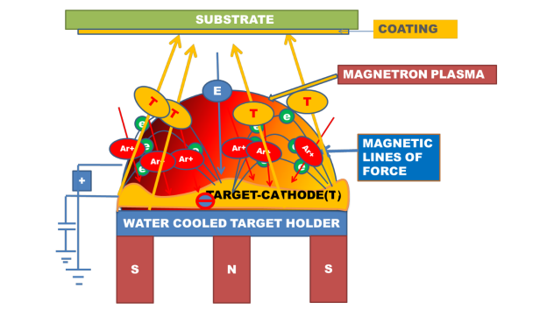Fig 1: Magnetron Sputtering System

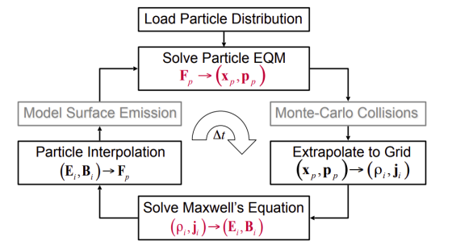

Fig 2: Simulation Flow Chart for PIC methods

## 

## 14

**List of Tables**

**Gantt Chart:**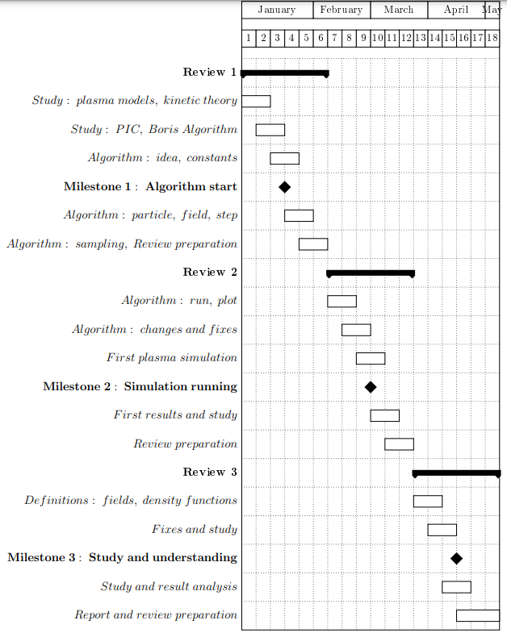

## 15

## References

[1] Chen, F. F., “**Introduction to plasma physics and controlled fusion**”, New York: Plenum press, 1984. - [6] Myers, A., Colella, P., & Straalen, B. V. (2017).

[2] Myers, A., Colella, P., & Straalen, B. V. (2017)., “**A 4th-Order Particle-in-Cell Method with Phase-Space Remapping for the Vlasov–Poisson Equation**” ,SIAM Journal on Scientific Computing, 39(3), B467-B485.

[3] Qin, H., Zhang, S., Xiao, J., & Tang, W. M. (April, 2013), “**Why is Boris algorithm so good?**” .Princeton Plasma Physics Laboratory, PPPL-4872.

**Other References**

[1]Na, Yong-Su (2017), “**Introduction to nuclear fusion**” (Lecture 9 Mirror, lecture slide). SeoulNational University Open Courseware.  
[2] Föreläsning (2009), “**Charged particle motion in magnetic field**” , (lecture slide). Luleä Uni-versity of Technology.   
[3] Professor Sitaram Dash. (Fall Semester 2021)., “**MEE4005 Surface Engineering**” (lecturenotes). SMEC, VIT Vellore.  
[4] Matthew W. Kunz. (November 9, 2020), “ **Introduction to Plasma Astrophysics**” (lecturenotes). Princeton Plasma Physics Laboratory. - we learned about introductory concepts on plasma

16